Integrated Math 1 HW #1 Name
For each set of values below, find the mean, median, mode, and range.
1. {12, -4, 5, 8, -16, -11, 8} Mean: _______ Median: __________ Mode: __________ Range: _________
2. {3.2, 5.8, 6.1, 3.2, 4.4} Mean: ________ Median: _________ Mode: _________ Range: _________
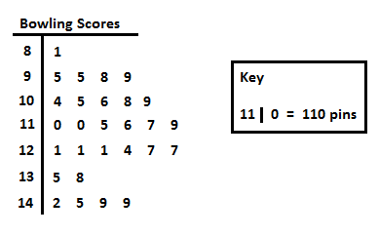
Use the stem-and-leaf plot below to answer the following questions.

3. What conclusion can you draw from the stem-and-leaf plot to the left?

4. How many pieces of data are there? ________ 5. What is the highest bowling score? ________
6. What is the lowest bowling score? ________ 7. What is the range of bowling scores? _______
8. What is the mode of the scores? ______ 9. What is the median score? ______
Use the following data for the questions below.
Home runs hit: 26, 18, 33, 29, 22, 4, 23, 36, 8, 6, 28, 25, 43, 38, 32, 30, 41
10. Create a stem-and-leaf plot of the data above. 11. What conclusion can you Make sure you have a title, key, and an accurate graph. draw from this stem-and-leaf?

12. What is the range of the data? _______ 13. What is the median of the data? _________

14. Explain how a stem-and-leaf plot can be helpful.

