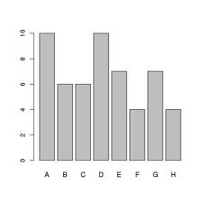**Integrated Math 1 HW #3**

1. Observe the graph at right.

a. Identify the missing characteristics from the graph

b. Write in reasonable values for the missing characteristics

2. Using ‘Our Favorite Sports’ Graph, answer the following questions.

a. What is the most popular sport for Girls?

b. What is the most popular sport for Boys?

c. What is the most popular sport overall?

d. What sport has the largest difference between boys and girls?

e. What is the total number of students represented by the data on this graph?

f. What is the total number of girls? boys?

**Find the mean, median, mode, and range for the data below.**

3. High Temperatures in July: 100, 95, 91, 95, 97, 84, 82, 76, 81, 84, 95, 95, 94, 97, 98, 97, 94, 94, 93



**Integrated Math 1 HW #3**

1. Observe the graph at right.

a. Identify the missing characteristics from the graph

b. Write in reasonable values for the missing characteristics

2. Using ‘Our Favorite Sports’ Graph, answer the following questions.



a. What is the most popular sport for Girls?

b. What is the most popular sport for Boys?

c. What is the most popular sport overall?

d. What sport has the largest difference between boys and girls?

e. What is the total number of students represented by the data on this graph?

f. What is the total number of girls? boys?

**Find the mean, median, mode, and range for the data below.**

3. High Temperatures in July: 100, 95, 91, 95, 97, 84, 82, 76, 81, 84, 95, 95, 94, 97, 98, 97, 94, 94, 93