**WS 1.3 Graphing and Writing Piecewise Functions Name: ___________________**

**Graph the following piecewise functions*:***

1.  2.  3. 

4.  5.  6. 

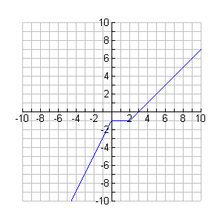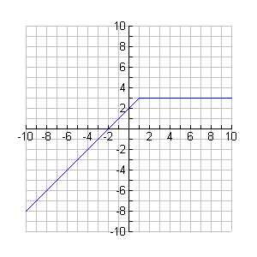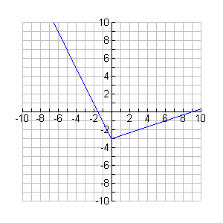**Write the equation of each piecewise function below. Then, write the domain and range using interval notation!**

7. 8. 9.

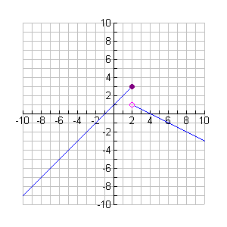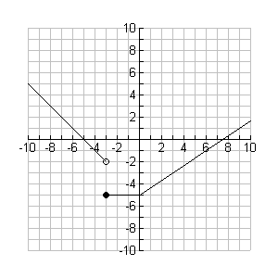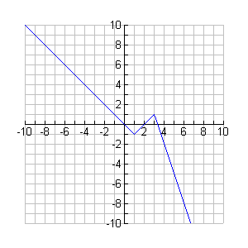

10. 11. 12.

**WS 1.3 Graphing and Writing Piecewise Functions Name: ___________________**

**Graph the following piecewise functions*:***

1.  2.  3. 

4.  5.  6. 

**Write the equation of each piecewise function below. Then, write the domain and range using interval notation!**

7. 8. 9.

**

10. 11. 12.